Market Monitor - Somalia - 2026-05

Highlights
Food prices continued their upward trend across Somalia in May 2026, with all monitored food commodities recording significant month-on-month and year-on-year increases, heightening concerns for household purchasing power.
The national average cost of the food basket increased by 6.9% month-on-month (MoM) and 22.1% year-on-year (YoY). The most significant monthly price increases were observed for imported rice (↑11.4%), cowpeas (↑8.9%), and white sorghum (↑7.7%).
Key drivers of inflation include:
- Broad-based inflation across food staples: Prices for all components of the food basket increased month-on-month, with imported rice, cowpeas, and sorghum experiencing the most significant hikes.
- Sustained high energy costs: While diesel prices were stable during the month, they remain 48.3% higher than the previous year. This high baseline cost continues to inflate transportation and production expenses, contributing to the high price of goods.
The exchange rate between the Somali Shilling (SOS) and the US Dollar remained stable and did not contribute to the observed price increases.
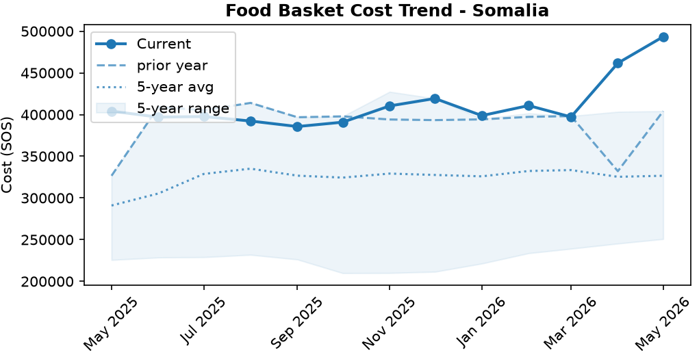
Food basket cost trend

Market Overview
Market conditions in May 2026 were characterized by significant and accelerating inflation, posing a severe threat to household purchasing power. The cost of the minimum food basket surged by 6.9% month-on-month and 22.1% year-on-year, driven by broad-based price hikes across all seven essential food commodities. This trend was primarily led by sharp increases in the prices of imported staples, particularly rice. A key underlying driver of this inflation remains the sustained high cost of energy; while diesel prices were stable month-on-month, they are 48.3% higher than last year, continuously elevating transportation and production costs. The stability of the Somali Shilling against the US dollar provided a crucial, albeit insufficient, buffer against even steeper price increases for imported goods. This quantitative data points to a deteriorating economic situation for vulnerable households, a conclusion supported by reports of rising child malnutrition and a credible risk of famine in Burhakaba District. These findings stand in contrast to a separate report noting improvements in food consumption, suggesting a complex and highly varied food security landscape across the country.

Commodity Analysis
Inflationary pressures were evident across the entire food basket in May, which saw its overall cost increase by 6.9% from the previous month. The most acute price shock was observed in imported rice, which surged by 11.4% month-on-month and a staggering 37.8% year-on-year, making it a principal driver of food inflation. Significant monthly price hikes were also recorded for key local and imported staples, including cowpeas (+8.9%), sorghum (+7.7%), sugar (+5.5%), and maize (+5.3%). The persistent rise in the cost of vegetable oil (+4.5% monthly, +21.3% annually) continues to strain household budgets. In contrast, wheat flour demonstrated the most price stability among food items, with only a minimal 1.5% monthly increase, offering slight relief amidst widespread inflation. Underlying these trends, the cost of fuel remains a critical factor. Although diesel prices were nearly flat month-on-month (+0.1%), the massive 48.3% year-on-year increase has entrenched high energy costs within the supply chain, contributing to the rising price of all commodities. The outlook suggests these upward price trends will continue, further eroding food security.
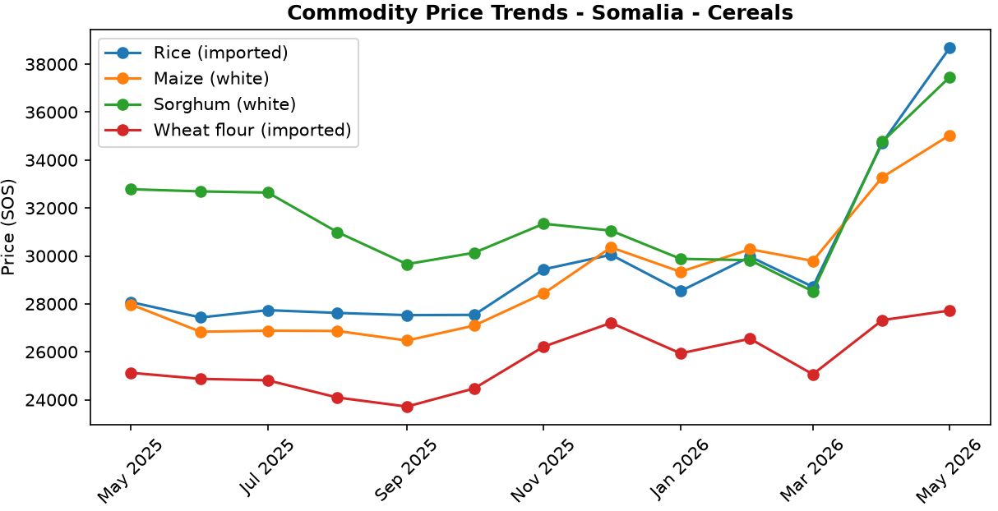
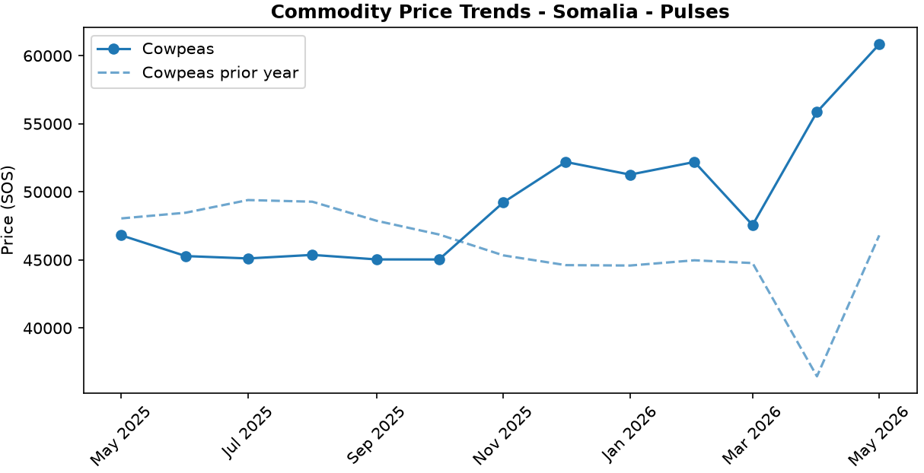
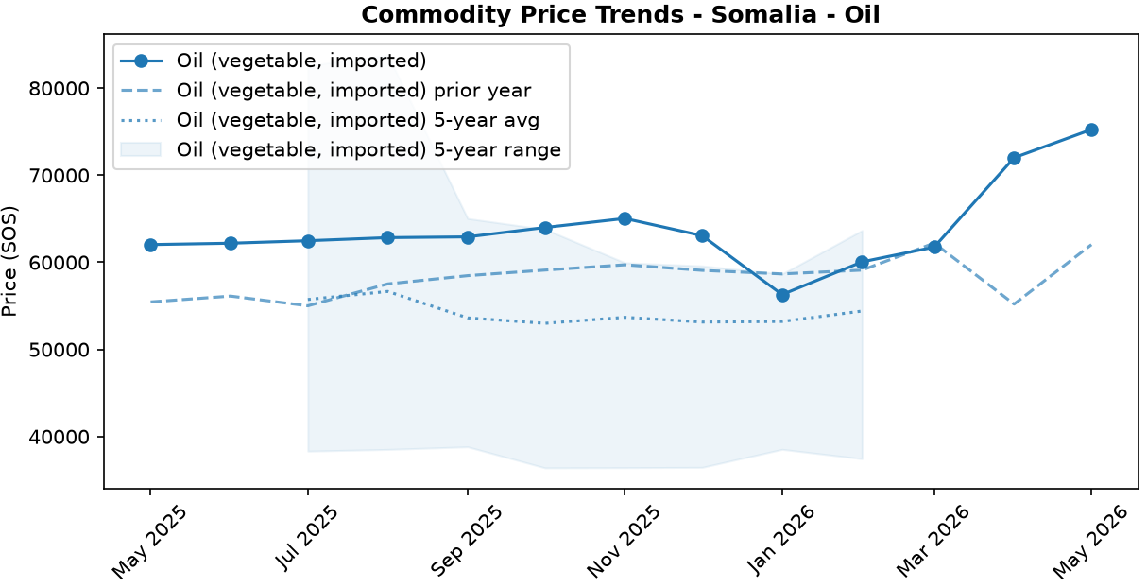
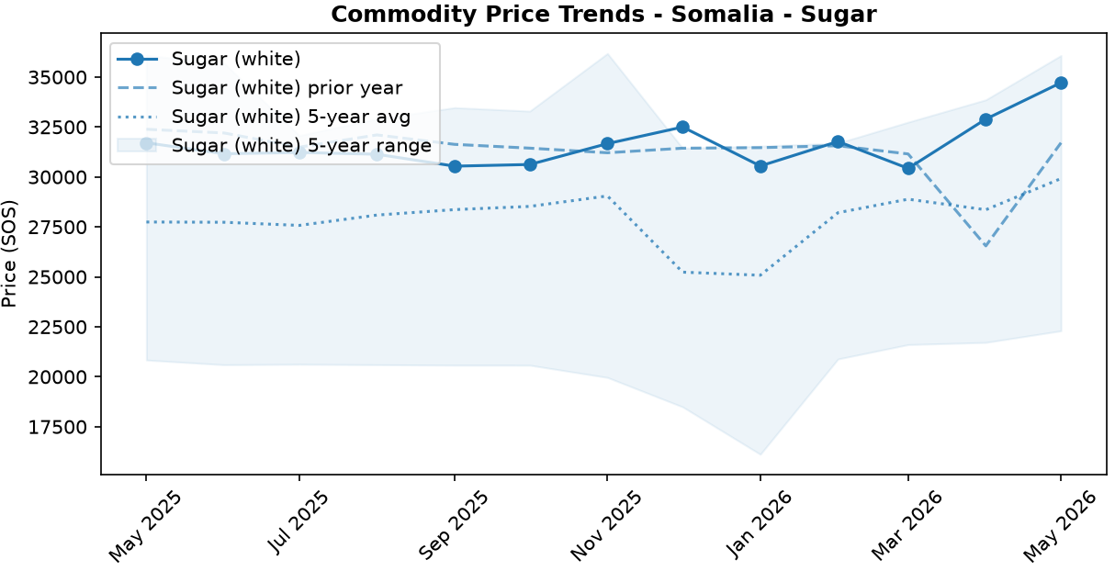

Regional Highlights
May data reveals extreme regional disparities in market conditions, most notably in the energy sector. A massive 111.1% price spread was recorded for diesel fuel between the country's highest and lowest-priced regions, signaling severe market fragmentation, logistical bottlenecks, and insecurity impacting supply chains. Bakool region recorded the nation's highest diesel prices at 62,514.17 SOS/Litre, more than double the price in Shabelle Hoose (29,616.67 SOS/Litre), the region with the lowest cost. These exorbitant fuel costs in areas like Bakool directly translate into higher transportation expenses, which in turn exacerbate local food price inflation and limit the reach of humanitarian aid. This economic pressure is consistent with recent alerts from the Integrated Food Security Phase Classification (IPC), which identified a credible risk of famine in the nearby Burhakaba District, and reports of rising malnutrition. The stark contrast in fuel prices underscores the uneven nature of economic stability and access to basic goods across Somalia.
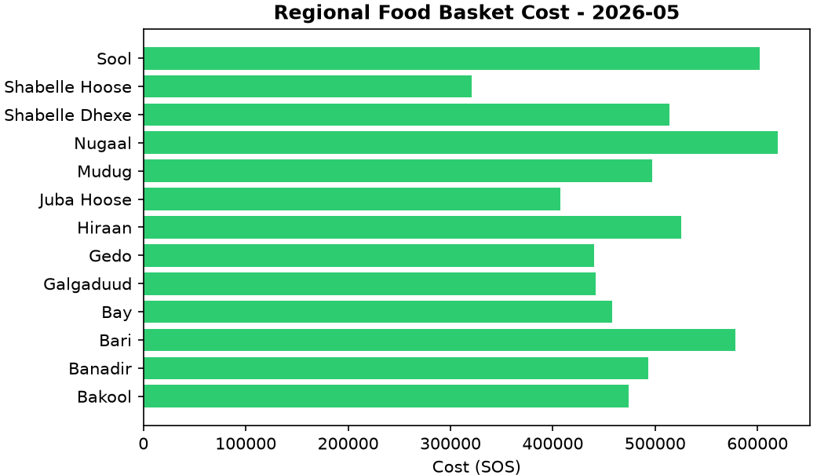

Exchange Rate Analysis
The Somali Shilling (SOS) remained stable against the US dollar, trading at 571.5 SOS per USD. The exchange rate recorded no change month-on-month (0.0%), which helps to prevent an increase in the cost of imported goods and provides a predictable environment for traders. Similarly, the currency showed no change compared to the same period last year (0.0% year-on-year), indicating a sustained period of stability and a flat long-term trajectory. This continued stability is crucial for containing imported inflation, as it helps to moderate upward pressure on the local prices of essential imported commodities. This is particularly important for key food items like wheat, rice, and cooking oil, as well as fuel, thereby supporting the purchasing power of vulnerable households who rely heavily on these goods.

Fuel & Energy
The national average price of diesel remained nearly stable in May 2026 at SOS 48,430 per litre, increasing by a marginal 0.1 percent month-on-month but remaining 48.3 percent higher than the same period last year. This monthly stability is consistent with administered pricing or broadly stable market conditions, though the high annual cost continues to exert upward pressure on transportation and food prices. These pressures are exacerbated by severe market fragmentation, evidenced by diesel prices in Bakool being more than double those in Shabelle Hoose, which likely contributes to higher food costs in remote areas.
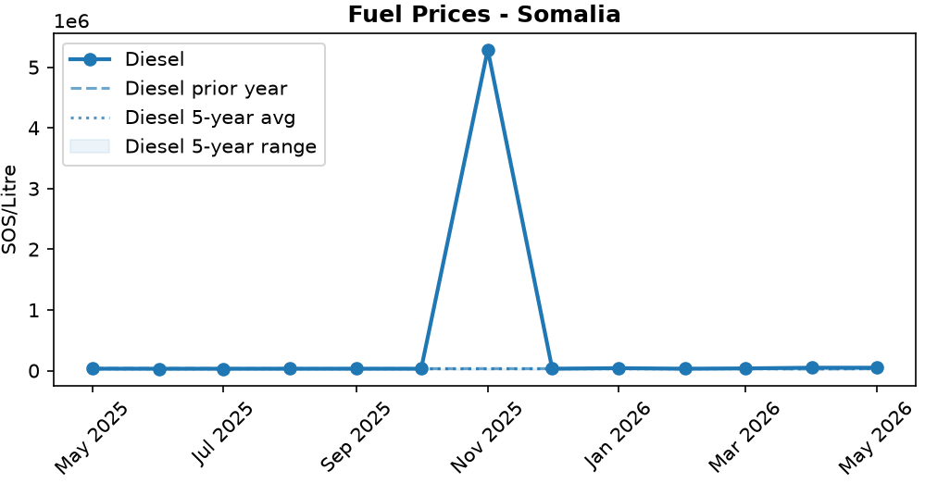
Fuel retail price trend

References
- [rw_4214041] ReliefWeb (2026-05-29) Somali Cash Consortium – Baseline and Endline Findings MPCA Outcomes from the Direct Nutrition Referral Approach: Gedo & Banadir regions, Somalia (November 2025)
https://reliefweb.int/node/4214041
- [rw_4213907] ReliefWeb (2026-05-28) Somalia: Emergency and Resilience Plan, 2026–2028
https://reliefweb.int/node/4213907
- [rw_4213862] ReliefWeb (2026-05-28) World Hunger Day: Urgent global action needed as hunger doubles in a decade
https://reliefweb.int/node/4213862
- [rw_4213744] ReliefWeb (2026-05-26) Somalia Faces Deepening Hunger Crisis as Risk of Famine Emerges in Burhakaba
https://reliefweb.int/node/4213744
- [rw_4213683] ReliefWeb (2026-05-26) Somalia: Diphtheria Outbreak - DREF Final Report (MDRSO024)
https://reliefweb.int/node/4213683
- [rw_4213549] ReliefWeb (2026-05-25) WFP Somalia Country Brief May 2026
https://reliefweb.int/node/4213549
- [rw_4213533] ReliefWeb (2026-05-25) Sexual Exploitation and Abuse (SEA) Joint Risk Assessment for Somalia - February 2025
https://reliefweb.int/node/4213533
- [rw_4213456] ReliefWeb (2026-05-25) Somalia Weekly Weather Forecast - Valid From 21 to 27 May 2026
https://reliefweb.int/node/4213456
- [rw_4213396] ReliefWeb (2026-05-24) Somalia - ARC Drought Insurance Payout Activation Bulletin: 2025–26 Deyr Season (May 2026)
https://reliefweb.int/node/4213396
- [rw_4213288] ReliefWeb (2026-05-22) Radio Ergo Weekly Feedback Report, Issued: 22 May 2026
https://reliefweb.int/node/4213288
- [seerist_1028776] Seerist (2026-05-29) Global maritime outlook: June 2026
- [seerist_1028721] Seerist (2026-05-27) Big Picture series: Carbon markets in Sub-Saharan Africa – growing opportunities amid regulatory, integrity challenges
- [seerist_1028607] Seerist (2026-05-19) Big Picture series: France’s push into anglophone Africa to bring new commercial opportunities despite West African controversies
- [seerist_1028580] Seerist (2026-05-18) Substantial ransoms to remain feature of Somali piracy following reported USD 10m demand
- [seerist_1028391] Seerist (2026-04-30) Global maritime outlook: May 2026
- [seerist_1028308] Seerist (2026-04-24) Local resistance, external pressure likely to undermine federal push to remove Jubaland administration
- [seerist_1028144] Seerist (2026-04-14) Big Picture series: Strait of Hormuz disruption to drive acute fiscal, supply chain challenges in Africa

